**PRACTICAL: 13(File Handling)**

**AIM: Write a program to perform various operations on file.**

**OBJECTIVES:**

**Implement a C++ program To merge two files, you have to ask to the user to**

**enter the three file name with extension.**

**(Note: Create three files and add some content in first two files. Now first open**

**the two files and start copying the content of first file to the third file(target file)**

**after this start appending the content of second file to the third file (target file).**

**Program should ask to the user to enter three file names. First file name and**

**second file name (say file1.txt and file2.txt), then Third file name that is used to**

**store the content of the two file (say filet.txt).)**

**Program:-**

#include <iostream>

#include <fstream>

using namespace std;

int main()

{ char file1[10],file2[20],file3[20];

cout<<"Enter the 1st file name with ext : "; cin>> file1;

cout<<"Enter the 2nd file name with ext : "; cin>> file2;

cout<<"Enter the 3rd file name with ext : "; cin>> file3;

ofstream File1(file1);

File1<<"I am a abhiraj ."<<endl;

ofstream File2(file2);

File2<<"I am a student ."<<endl;

ofstream File3(file3,ios::app);

ifstream f1(file1);

ifstream f2(file2);

ifstream f3(file3);

try{

char a[100];

while(f1>>a){

File3<<a<<" ";

}

File3<<endl;

while(f2>>a){

File3<<a<<" ";

}

throw 1;

}

catch(...){

cout<<"The 2 files were merged successfully ."<<endl;

return 0;

}

**OUTPUT:-**

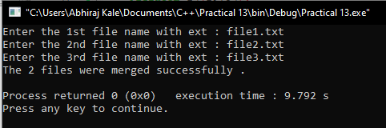

**Conclusion:-**

**Thus, we have successfully written a program to perform various operations on file.**